Icon Updating
- Hold pressing PTT key and PF2 key (the bottom side key), at the same time power on radio, LCD display UPDATE MODE
- Use PC cable connect PC to radio
- Double click on QXCodePro_Update.exe to run it
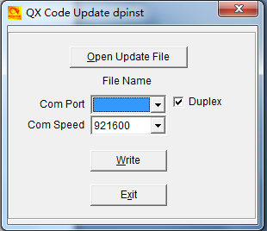
- Click Open Update File，D868_1G_ICON_V1.11.spi
- Com Speed 921600, tick on Duplex
- Click Write to update the radio the latest firmware.
- Reboot the radio when the update is finished.

